Deep convolutional Neural Networks for
Sentiment Analysis of Short Texts

Cicero Nogueira Santos
Brazilian Research Lab
IBM Research
cicerons@br.ibm.com

Maira Gatti
Brazilian Research Lab
IBM Research
mairacg@br.ibm.com

DOMAIN: SSTb (Stanford Sentiment Tree Bank)
, STS (Stanford Twitter Sentiment corpus)

Introduction
Sentiment analysis of short texts such as single sentences and Twitter messages is challenging because of the limited contextual in formation that they normally contain. Effectively solving this task requires strategies that combine the small text content with prior knowledge and use more than just bag-of-words. Additionally, to ﬁll the gap of contextual information in a scalable manner, it is more suitable to use methods that can exploit prior knowledge from large sets of unlabeled texts. In this work we propose a deep convolutional neural network that exploits from character to sentence level information to perform sentiment analysis of short texts. The proposed network, named Character to Sentence Convolutional Neural Network (CharSCNN), uses two convolutional layers to extract relevant features from words and sentences of any size. The proposed network can easily explore the richness of word embedding produced by unsupervised pre-training (Mikolov et al., 2013). We perform experiments that show the effectiveness of CharSCNN for sentiment analysis of texts from two domains: movie review sentences; and Twitter messages. CharSCNN achieves state-of-the-art results for the two domains. Additionally, in our experiments we provide information about the usefulness of unsupervised pre-training; the contribution of character-level features; and the effectiveness of sentence-level features to detect negation.

Methodology
Given a sentence, CharSCNN computes a score for each sentiment label τ ∈ T. In order to score a sentence, the network takes as input the sequence of words in the sentence, and passes it through a sequence of layers where features with increasing levels of complexity are extracted. The network extracts features from the character-level up to the sentence-level. The main novelty in our network architecture is the inclusion of two convolutional layers, which allows it to handle words and sentences of any size.

Initial Representation Levels:
The ﬁrst layer of the network transforms words into real-valued feature vectors that capture morphological, syntactic and semantic information about the words.

Word-Level Embedding:
Word-level embedding are encoded by column vectors in an embedding matrix. Each column corresponds to the word-level embedding of the i-th word in the vocabulary. We transform a word w into its word-level embedding by using the matrix-vector product.

Character-Level Embedding:
The convolutional approach produces local features around each character of the word and then combines them using a max operation to create a ﬁxed-sized character-level embedding of the word.

Sentence-Level Representation and Scoring:
This second convolutional layer in our neural network architecture works in a very similar way to the one used to extract character-level features for words. This layer produces local features around each word in the sentence and then combines them using a max operation to create a ﬁxed-sized feature vector for the sentence.

Related Work
In (Socher et al., 2011) the authors proposed a semi-supervised approach based on recursive auto encoders for predicting sentiment distributions. The method learns vector space representation for multi-word phrases and exploits the recursive nature of sentences.
In (Socher et al., 2012), it is proposed a matrix-vector recursive neural network model for semantic compositionality, which has the ability to learn compositional vector representations for phrases and sentences of arbitrary length. The vector captures the inherent meaning of the constituent, while the matrix captures how the meaning of neighboring words and phrases are changed.
Comparison:
In (Socher et al., 2013b) the authors propose the Recursive Neural Tensor Network (RNTN) architecture, which represents a phrase through word vectors and a parse tree and then compute vectors for higher nodes in the tree using the same tensor-based composition function.
Our approach differ from these previous works because it uses a feed-forward neural network instead of a recursive one. Moreover, it does not need any input about the syntactic structure of the sentence.

Sentiment Analysis Datasets

We apply CharSCNN for two different corpora from two different domains: movie reviews and Twitter posts.
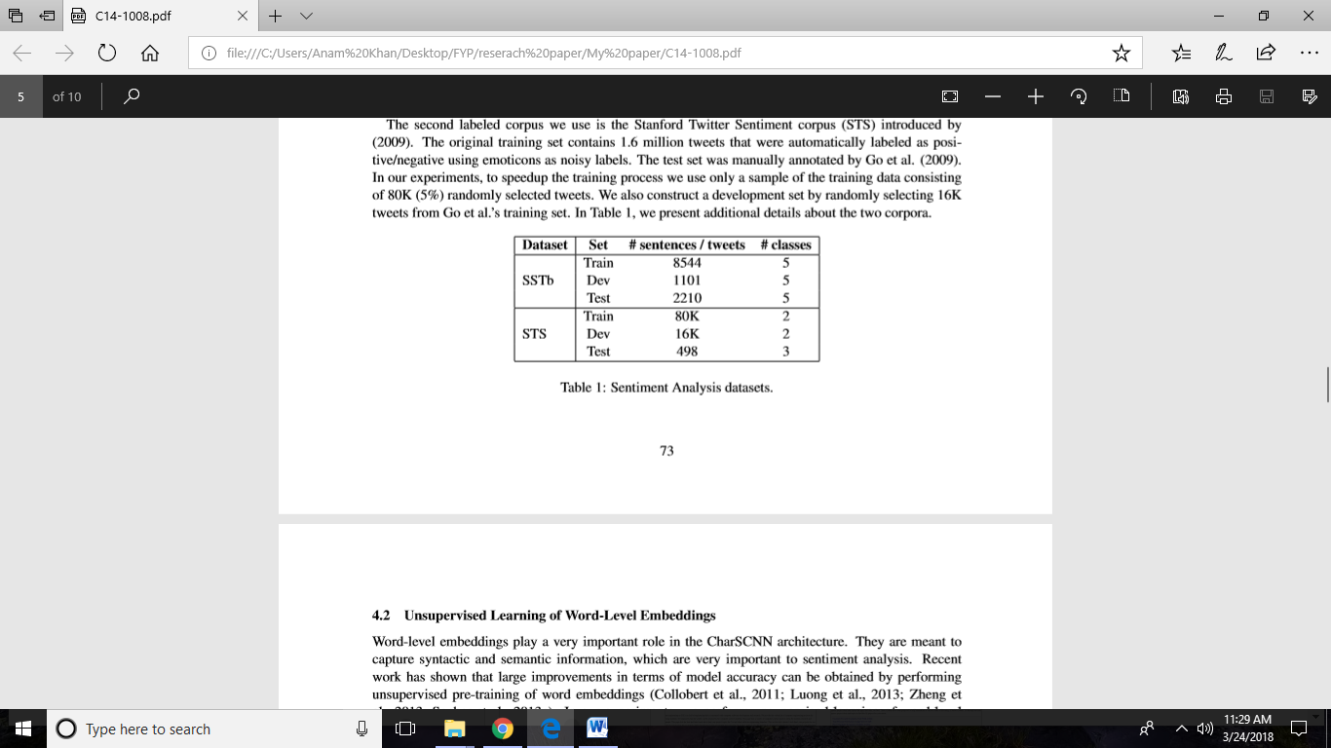

Unsupervised Learning of Word-Level Embedding

In our experiments, we perform unsupervised learning of word-level embeddings using the word2vec tool3, which implements the continuous bag-of-words and skip-gram architectures for computing vector representations of words (Mikolov et al., 2013). We use the December 2013 snapshot of the English Wikipedia corpus as a source of unlabeled data.
The Wikipedia corpus has been processed using the following steps:
(1) removal of paragraphs that are not in English; (2) substitution of non-western characters for a special character;
(3) tokenization of the text using the tokenizer available with the Stanford POS Tagger (Manning, 2011);
(4) and removal of sentences that are less than 20 characters long (including white spaces) or have less than 5 tokens. There are 94 different characters in the SSTb corpus and 453 different characters in the STS corpus. Since the two character vocabularies are relatively small, it has been possible to learn reliable character-level embedding using the labeled training corpora. The raw (not lowercased) words are used to construct the character vocabularies, which allow the network to capture relevant information about capitalization.

Model Setup
In order to assess the effectiveness of the proposed character-level representation of words, we compare the proposed architecture CharSCNN with an architecture that uses only word embedding.

Result for SSTb Corpus
For the SSTb corpus, our approach achieves state-of-the-art results for single sentence sentiment prediction in both binary positive/negative classiﬁcation, with 85.7% accuracy, and ﬁne-grained classiﬁcation, with 48.3%accuracy.

Results for STS Corpus
For the STS corpus, our approach achieves a sentiment prediction accuracy of 86.4%.

Conclusions
In this work we present a new deep neural network architecture that jointly uses character-level, word level and sentence-level representations to perform sentiment analysis. The main contributions of the paper are: (1) the idea of using convolutional neural networks to extract from character- to sentence level features; (2) the demonstration that a feed-forward neural network architecture can be as effective as RNTN (Socher et al., 2013a) for sentiment analysis of sentences; (3) the deﬁnition of new state-of the-art results for SSTb and STS corpora.
As future work, we would like to analyze in more detail the role of character-level representations for sentiment analysis of tweets. Additionally, we would like to check the impact of performing the unsupervised pre-training step using texts from the speciﬁc domain at hand.

